NAME ______________________________________________ DATE ___________________________

What is Government?

The word GOVERNMENT is heard by all of us almost every day. But do we know what government is? Let’s take a minute to discuss GOVERNMENT in general terms, then move on to our government in Pennsylvania.

So what is government? Click on the word [government](http://www.merriam-webster.com/dictionary/government?show=0&t=1399242071). After reading the definitions in the gray box, write a definition in your own words. __________________________________________________

________________________________________________________________________________

**How does the United States government work?** Go to <http://kids.usa.gov/three-branches-of-government/index.shtml> and answer the following questions.

1. How many branches of the United States government are there? ________

2. Congress includes two parts. What are they?

_____________________________________ ___________________________________

3. The Executive branch of government is headed by whom? _____________________________

4. Congress is part of which branch of government? ___________________________________

5. What does the Supreme Court do? _________________________________________________

PENNSYLVANIA GOVERNMENT

The Commonwealth of Pennsylvania is one of the original thirteen colonies and subsequently became one of the original states forming the United States of America. William Penn wrote the “Frameworks of Government” which provided the initial governing structure for the colony.

As tension between the colonies and England rose, the government in the colony was being attacked. Ultimately, in 1776 a new framework for governing Pennsylvania was adopted. This constitution, although considered the most democratic in the colonies, was replaced in 1790.

Read about the Pennsylvania’s governmental structure at Encyclopedia Britannica Online. Find the link on the school Library webpage in the Research folder. Type PENNSYLVANIA in the Search Box for Middle School. Once the article loads, click on Government on the left-hand side of the page.

Answer the following questions:

1. What is the Chief Executive of Pennsylvania called? __________________________

For how long is this person elected? _________

2. The Legislative Branch or General Assembly has two chambers. Name them:

A. ____________________________ B. ____________________________

3. The Judicial branch includes a Supreme Court. How many judges sit on the Supreme Court of Pennsylvania? ________

The state government is similar to the national government. They both have the same number of branches. Based upon the questions you answered and what you know about our national government, how many branches are there? ______

We elect our government officials.

Name them: (Click on the links for each.)

[Governor](http://www.pa.gov/Pages/default.aspx): ________________________________________________

[State Senator](http://www.legis.state.pa.us/): _____________________________________________

[State Representative](http://www.legis.state.pa.us/): ______________________________________

Our state also has other governing organizations which help provide services to the citizens of Pennsylvania. These include County, Township, and city or boroughs. Let’s learn a little about County and Borough governments.

**The History of Counties**

[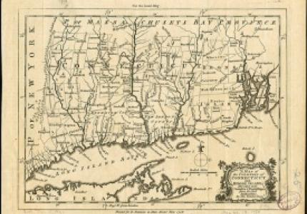](http://www.factmonster.com/ce6/history/A0813791.html)

Counties are part of our system of local government. They respond to local community needs, while also supporting the state and federal governments. County responsibilities may include responding to emergencies, law enforcement, paving and repairing roads, creating and managing parks, and making sure we all have clean water to drink– just to name a few! Where did counties come from and how did they develop these responsibilities?

Go to the link below and answer the following question.

Question: Where and when did the system of counties begin?

Webquest Link:

[The History of Counties](http://www.factmonster.com/encyclopedia/history/county.html)

ANSWER: ____________________________________

______________________________________________

**Counties Across the United States**

[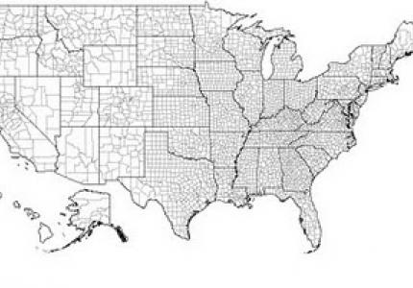](http://www.charlestoncounty.org/stats/bystate.htm)

Do you live in a county? It might be called a parish if you live in Louisiana or a borough if you’re in Alaska! Some cities have incorporated to form their own governments, separate from the county. In fact, in some states, counties don’t actually have functioning county governments. No matter what they are called, there are a lot of counties and county equivalents in the U.S. Check out the list:

**Webquest Link:**  [**Counties by State**](http://www.clickandlearn.cc/FreeBlacklineMaps/Counties.htm)

**QUESTION:** How many counties are there in Pennsylvania? _____________

#### **Our County**

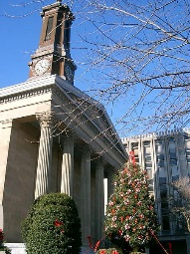

#### Now that you’ve learned about the history, and number of counties in Pennsylvania, it’s time to take a look at your own county! The National Association of Counties has developed a website that will help you find facts about your county, and even help you explore your own county webpage. **Webquest Link:** [Chester County Facts](http://www.chesco.org/892/Facts-About-Chester-County)

Follow the link and use the map to find your county. Create a profile of your county that includes the following information:

|  |  |
| --- | --- |
| COUNTY NAME |  |
| YEAR ESTABLISHED |  |
| 2010 POPULATION |  |
| COUNTY SEAT |  |
| NUMBER OF COUNTY COMMISIONERS |  |

**MY COUNTY SEAT**

**An Example of Municipal Government**

Look up the word **municipality** at <http://dictionary.reference.com/browse/municipality?s=t>

What does it mean? ___________________________________________________

____________________________________________________________________

What is Chester County’s seat? _________________________________________

Let’s explore a city’s government. Click on <http://www.west-chester.com/> and listen to the video about community services. Answer the following questions.

What is the main governing body? _______________________________________

How many representatives are on the Borough Council? __________

Who is the Mayor of West Chester? _________________________________________

How long has this person been mayor? _______________________________________

What department does the Mayor direct? ______________________________________